The Karnaugh map, also known as the K-map, is a method to simplify boolean algebra expressions. Maurice Karnaugh introduced it in 1953
A Karnaugh map (K-map) is a pictorial method used to minimize Boolean expressions without having to use Boolean algebra theorems and equation manipulations. A K-map can be thought of as a special version of a truth table .
Using a K-map, expressions with two to four variables are easily minimized. Expressions with five to six variables are more difficult but achievable, and expressions with seven or more variables are extremely difficult (if not impossible) to minimize using a K-map.

12. Karnaugh Maps

The map method provides a simple straightforward procedure for minimizing Boolean functions. This method may be regarded either as a pictorial form of a truth table or as an extension of the Venn diagram. The map method, first proposed by Veitch and slightly modified by Karnaugh, is also known as the “Veitch diagram” or the Karnaugh map.”

The map is a diagram made up of squares. Each square represents one minterm.
Using a K-map, expressions with two to four variables are easily minimized. Expressions with five to six variables are more difficult but achievable, and expressions with seven or more variables are extremely difficult (if not impossible) to minimize using a K-map.
Minterms
- Minterms are AND terms with every variable present in either true or complemented form.
- Given that each binary variable may appear normal (e.g., x) or complemented (e.g., ), there are 2^{n} minterms for n variables.
- Example: Two variables (X and Y) produce
2 x 2 = 4 combinations:
(both normal)
(X normal, Y complemented)
(X complemented, Y normal)
(both complemented)
- Thus there are four minterms of two variables.

TWO – AND THREE –Variable Maps

A two-variable map is shown in Fig. (a) below. There are four minterms for two variables; hence the map consists of four squares, one for each minterm. The map is redrawn in Fig. (b) to show the relationship between the squares and the two variables.

y
y
x
1
0
m₀ | m₁  0
m₂ | m₃  1  x

x’y’ | x’y
xy’ | xy
(a)

(b)
Fig. Two-variable map

The 0’s and 1’s marked for each row and each column designate the values of variables x and y respectively. Notice that x appears primed in row 0 and unprimed in row 1. Similarly, y appears primed in column 0 and unprimed in column 1.

y
y
y
y
1
0
1
0
x
x
0
1  x | 1  x

 | 1
1 | 1
(a) xy
0
1
(b) x + y
Fig. Representation of function in the map

A three-variable map is shown in fig. below
y
yz
x
00
01
11
10

m₀ | m₁ | m₃ | m₂  0
m₄ | m₅ | m₇ | m₆  x  1

x’y’z’ | x’y’z | x’yz | x’yz’
xy’z’ | xy’z | xyz | xyz’
z
(a)
(b)
Fig. Three-variable map

There are eight minterms for three binary variables. Therefore, a map consists of eight squares. Note that the minterms are arranged, not in a binary sequence. It is one of the many possible sequences. The characteristic of this sequence is that only one bit changes from 1 to 0 or from 0 to 1 in the listing sequence. The map drawn in part (b) is marked with numbers in each row and each column to show the relationship between the squares and the three variables. For example, the square assigned to m₅ corresponds to row 1 and column 01. When these two numbers are concatenated, they give the binary number 101, whose decimal equivalent is 5.

Another way of looking at square m₅ = xy’z is to consider it be in the row marked x and the column belonging to y’z (column 01). Note that there are four squares where each variable is equal to 1 and four where each is equal to 0. The variable appears unprimed in those four squares where it is equal to 1 and primed in those squares where it is equal to 0. For convenience, we write the variable with its letter symbol under the four squares where it is unprimed.

Hence, Karnaugh Maps are used for Logic Simplification. We saw that any logic function can be obtained directly from the truth table. The obvious method is to give the logic function in terms of each row in the truth table for which the output function f is a 1. Each row is the "product" of the input variables (A if the entry is a 1 and A’ if the entry is a 0).

3A.2 DESCRIPTION OF KMAPS AND TERMINOLOGY

Karnaugh maps, or Kmaps, are a graphical way to represent Boolean functions. If a product term includes all of the variables exactly once, either complemented or not complemented, this product term is called a minterm. For example, if there are two input values, x and y, there are four minterms, x’y’, x’y, xy’, and xy, which represent all of the possible input combinations for the function. If the input variables are x, y, and z, then there are eight minterms: x’y’z’, x’y’z, x’yz’, x’yz, xy’z’, xy’z, xyz’, and xyz.

As an example, consider the Boolean function F(x,y) = xy + x’y. Possible inputs for x and y are shown in Figure 3A.1. The mintermx’y’ represents the input pair (0,0). Similarly, the minterm x’y represents (0,1), the minterm xy’ represents (1,0), and xy represents (1,1). The minterms for three variables, along with the input values they represent, are shown in Figure 3A.2.

A Kmap is a table with a cell for each minterm, which means it has a cell for each line of the truth table for the function. Consider the function F(x,y) = xy and its truth table, as seen in Example 3A.1.
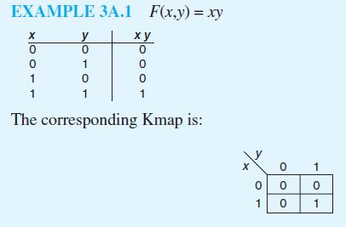
Notice that the only cell in the map with a value of one occurs when x = 1 and y = 1, the same values for which xy = 1. Let’s look at another example, F(x,y) = x + y.

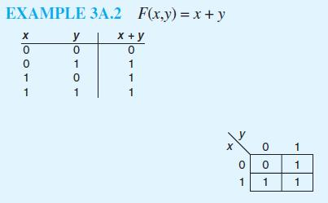
Three of the minterms in Example 3A.2 have a value of 1, exactly the minterms for which the input to the function gives us a 1 for the output. To assign 1s in the Kmap, we simply place 1s where we find corresponding 1s in the truth table. We can express the function F(x,y) = x + y as the logical OR of all minterms for which the minterm has a value of 1. Then F(x,y) can be represented by the expression x’y + xy’+ xy Obviously, this expression is not minimized (we already know this function is simply x + y). We can minimize using Boolean identities:

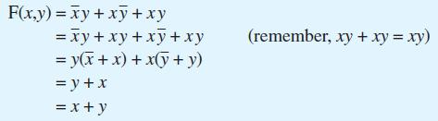
How did we know to add in an extra xy term? Algebraic simplification using
Boolean identities can be very tricky. This is where Kmaps can help.
KMAP SIMPLIFICATION FOR TWO VARIABLES

To use this map to reduce a Boolean function, we simply need to group ones. This grouping is very similar to how we grouped terms when we reduced using Boolean identities, except we must follow specific rules.
- First, we group only ones.
- Second, we can group ones in the Kmap if the ones are in the same row or in the same column, but they cannot be on the diagonal (i.e., they must be adjacent cells).
- Third, we can group ones if the total number in the group is a power of 2.
- The fourth rule specifies we must make the groups as large as possible.
- As a fifth and final rule, all ones must be in a group (even if some are in a group of one). Let’s examine some correct and incorrect groupings, as shown in Figures 3A.4 through 3A.7.

Notice in Figure 3A.6(b) and 3A.7(b) that one 1 belongs to two groups. This is the map equivalent of adding the term xy to the Boolean function, as we did when we were performing simplification using identities. The xy term in the map will be used twice in the simplification procedure. To simplify using Kmaps, first create the groups as specified by the rules above. After you have found all groups, examine each group and discard the variable that differs within each group. For example, Figure 3A.7(b) shows the correct grouping for F(x,y) = x + y. Let’s begin with the group represented by the second row (where x = 1). The two minterms are xy’ and xy. This group represents the logical OR of these two terms, or xy’ + xy. These terms differ in y, so y is discarded,

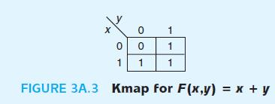
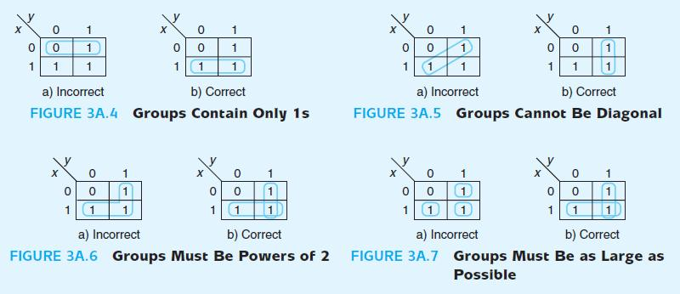
leaving only x. (We can see that if we use Boolean identities, this would reduce to the same value. The Kmap allows us to take a shortcut, helping us to automatically discard the correct variable.) The second group represents x’y + xy. These differ in x, so x is discarded, leaving y. If we OR the results of the first group and the second group, we have x + y, which is the correct reduction of the original function, F.

KMAP SIMPLIFICATION FOR THREE VARIABLES
Kmaps can be applied to expressions of more than two variables. In this focus section, we show three-variable and four-variable Kmaps.
The first difference you should notice is that two variables, y and z, are grouped together in the table. The second difference is that the numbering for the columns is not sequential. Instead of labeling the columns as 00, 01, 10, 11 (a normal binary progression), we have labeled them 00, 01, 11, 10. The input values for the Kmap must be ordered so that each minterm differs in only one variable from each neighbor. By using this order (for example 01 followed by 11), the

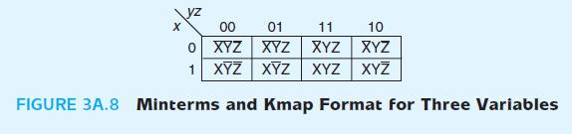
Corresponding minterms, x’y’z and x’yz, differ only in the y variable. Remember, to reduce, we need to discard the variable that is different. Therefore, we must ensure that each group of two minterms differs in only one variable. It is possible to have groups of four or even eight 1s, depending on the function. Let’s look at a couple of examples of map simplification for expressions of three variables.

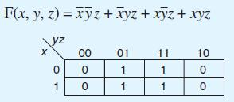
We again follow the rules for making groups. You should see that you can make groups of two in several ways. However, the rules stipulate we must create the largest groups whose sizes are powers of two. There is one group of four, so we group these as follows:
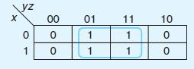
It is not necessary to create additional groups of two. The fewer groups you have, the fewer terms there will be. Remember, we want to simplify the expression, and all we have to do is guarantee that every 1 is in some group.

How, exactly, do we simplify when we have a group of four 1s? Two 1s in a group allowed us to discard one variable. Four 1s in a group allows us to discard two variables: The two variables in which all four terms differ. In the group of four from the preceding example, we have the following minterms: x’y’z, x’yz, xy’z and xyz. These all have z in common, but the x and y variables differ. So we discard x and y, leaving us with F(x,y,z) = z as the final reduction. To see how this parallels simplification using Boolean identities, consider the same reduction using identities. Note that the function is represented originally as the logical OR of the minterms with a value of 1.

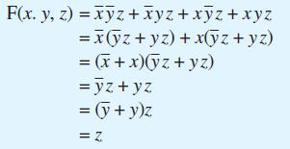
The end result using Boolean identities is exactly the same as the result using map simplification.
From time to time, the grouping process can be a little tricky. Let’s look at an example that requires more analysis.

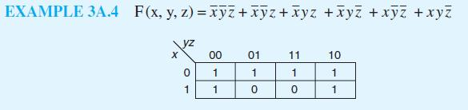
This is a tricky problem for two reasons: We have overlapping groups, and we have a group that “wraps around.” The leftmost 1s in the first column can be grouped with the rightmost 1s in the last column, because the first and last columns are logically adjacent (envision the map as being drawn on a cylinder). The first and last rows of a Kmap are also logically adjacent, which becomes apparent when we look at four-variable maps in the next section. The correct groupings are as follows:

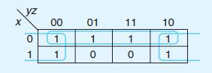
The first group reduces to x’ (this is the only term the four have in common), and the second group reduces to z’, so the final minimized function is F(x,y,z) =x’ + z’.

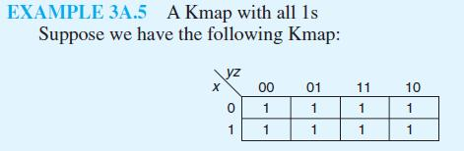
The largest group of 1s we can find is a group of eight, which puts all of the 1s in the same group. How do we simplify this? We follow the same rules we have been following. Remember, groups of two allowed us to discard one variable, and groups of four allowed us to discard two variables; therefore, groups of eight should allow us to discard three variables. But that’s all we have! If we discard all the variables, we are left with F(x,y,z) = 1. If you examine the truth table for this function, you will see that we do indeed have a correct simplification.

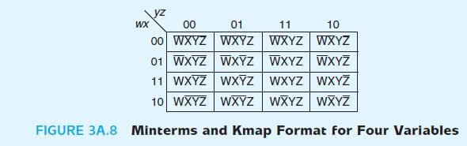
KMAP SIMPLIFICATION FOR FOUR VARIABLES

We now extend the map simplification techniques to four variables. Four variables give us 16 minterms, as shown in Figure 3A.8. Notice the special order of 11 followed by 10 applies for the rows as well as the columns.

Example 3A.6 illustrates the representation and simplification of a function with four variables. We are only concerned with the terms that are 1s, so we omit entering the 0s into the map.

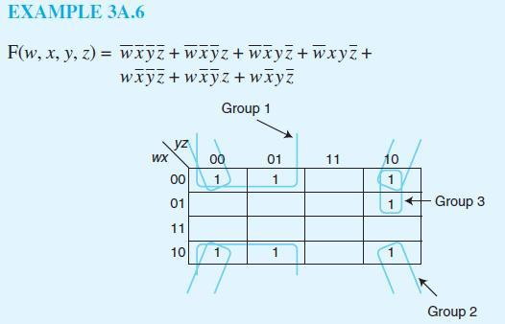
Group 1 is a “wrap-around” group, as we saw previously. Group 3 is easy to find as well. Group 2 represents the ultimate wrap-around group: It consists of the 1s in the four corners. Remember, these corners are logically adjacent. The final result is that F reduces to three terms, one from each group: x’y’ (from Group 1), x’z’(from Group 2), and w’yz’(from Group 3). The final reduction for F is then F(w, x, y, z) = x’y’+ x’z’+ w’yz’.

Occasionally, there are choices to make when performing map simplification. Consider Example 3A.7.
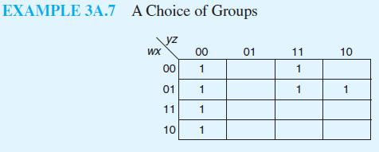
The first column should clearly be grouped. Also, the w’x’yz and w’xyz terms should be grouped. However, we have a choice as to how to group the w’xyz’ term. It could be grouped with w’xyz or with w’xy’z’ (as a wrap-around). These two solutions are indicated below.
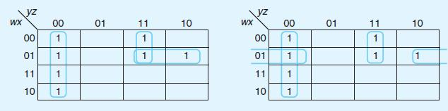
The first map simplifies to F(w, x, y, z) = F1 = y’z’ + w’yz + w’xy. The second map simplifies to F(w, x, y, z) = F2 = y’z’ + w’yz + w’xz’. The last terms are different. F1 and F2, however, are equivalent. We leave it up to you to produce the truth tables for F1 and F2 to check for equality. They both have the same number of terms and variables as well. If we follow the rules, Kmap minimization results in a minimized function (and thus a minimal circuit), but these minimized functions need not be unique in representation.

Here are the rules for Kmap simplification.

1. The groups can only contain 1s; no 0s.
2. Only 1s in adjacent cells can be grouped; diagonal grouping is not allowed.
3. The number of 1s in a group must be a power of 2.
4. The groups must be as large as possible while still following all rules.
5. All 1s must belong to a group, even if it is a group of one.
6. Overlapping groups are allowed.
7. Wrap around is allowed.
8. Use the fewest number of groups possible.
Using these rules, let’s complete one more example for a four-variable function. Example 3A.8 shows several applications of the various rules.

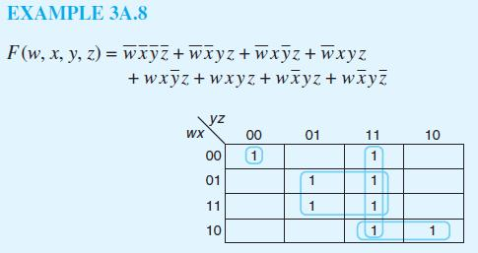
In this example, we have one group with a single element. Note there is no way to group this term with any others if we follow the rules. The function represented by this Kmap simplifies to F(w, x, y, z) = yz + xz + wx’y + w’x’y’z’.

If you are given a function that is not written as a sum of minterms, you can still use Kmaps to help minimize the function. However, you have to use a procedure that is somewhat the reverse of what we have been doing to set up the Kmap before reduction can occur. Example 3A.9 illustrates this procedure.

EXAMPLE 3A.9 A Function Not Represented as a Sum of Minterms

Suppose you are given the function F(w, x, y, z) = w’xy + w’x’yz + w’x’yz’. The last two terms are minterms, and we can easily place 1s in the appropriate positions in the Kmap. However the term w’xy is not a minterm. Suppose this term were the result of a grouping you had performed on a Kmap. The term that was discarded was the z term, which means this term is equivalent to the two terms w’xyz’ + w’xyz. You can now use these two terms in the Kmap, because they are both
minterms. We now get the following Kmap:
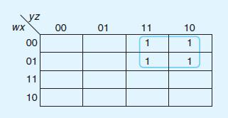
So we know the function F(w, x, y, z) = w’xy + w’x’yz + w’x’yz’ simplifies to F(w, x, y, z) = w’y.

up with a simplification of F2(w, x, y, z) = w'z + yz. Notice that in this case, F1 and F2 are not equal. However, if you create the truth tables for both functions, you should see that they are not equal only in those values for which we “don’t care.”

Thus we have seen Kmaps and map simplification. Using Boolean identities for reduction is awkward and can be very difficult.. Kmaps, on the other hand, provide a precise set of steps to follow to find the minimal representation of a function, and thus the minimal circuit that function represents.
